LEXINGTON Seat Sofa

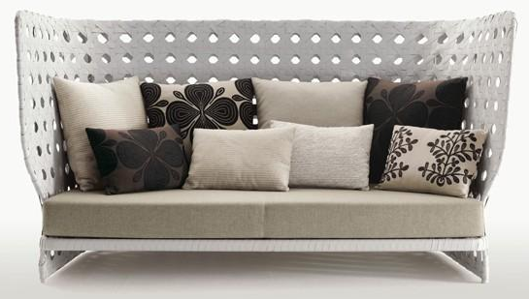

|  |
| --- |
| **DESCRIPTION** |
| Seat Sofa produced by LEXINGTON Sofa Company, presents a hand stitched very comfortable wooden seat sofa. The metallic paint applied on long curved seat makes it appear good and relaxing in front of the users. High Spring Cushion Makes this sofa even more special because of the king look this sofa becomes more presentable. |

|  |  |  |
| --- | --- | --- |
| **Price** | **1525$** | |
| **Dimensions** | **H** x **W** x **L** | **20in x 31in x 54in** |
| **Features** | **It is build for two but four people can also sit at once. And number of cushion which is included is eight so that you can relax.** | |
| **Finished** | **Round back** | |
| **Available in** | **White and Light Green** | |